November 2nd, 2007
Hi
Not really much to write about – though I have said that in the past and ended up writing quite a lot.

I was supposed to have a telephone conference call this afternoon involving the several people from the team overseeing the writing of the Indonesian primary science books. However, that will now not take place due to the usual problem for such things of not being able to get everybody available at the same time. I am supposed to fly to Singapore on Tuesday 11th and to Jakarta the following day but cannot book tickets as there are connecting flights and I have not yet heard from the organiser when these are. Because I will get a cheaper ticket, additional payments would be necessary to change flights. While in Indonesia, I will visit some primary schools to give demonstration lessons to four P3 classes on how to use English as a medium of instruction in the teaching of science to second-language children. Also, there will be talks/presentations to both primary and secondary teachers on the same topic plus plugging the books the Singapore publisher is trying to sell in Indonesia together with principles from education psychology I have used to write the (secondary books for Singapore).
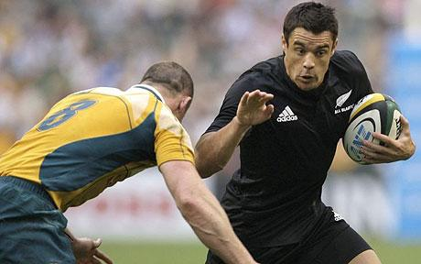

In Hong Kong yesterday, the final Bledisloe Cup match between NZ and Australia was played in HK. NZ won 19-14 after being down 14-9 at the end of the first half. They were very 'rusty' in the first half not having played or trained together for about a month, in contrast to the Australians who had trained a lot. The cup was not at stake as NZ had already retained it from victories in previous games. This is the first time a test between the two countries has been play outside either of NZ or Australia. They have had invitations to play in Denver and Tokyo in the next two years. Today the ABs fly to the UK for tests on each of the next four weekends against Scotland, Ireland, Wales and England. Australia has a similar tour beginning with a test against Italy next Saturday.
Also in HK, the average temperature for October was the highest on record! Average temperatures here are on the increase.
I liked the mail you sent to me Nadine of the personalised Obama political advertisement. It had me fooled for a while that there was some guy in the US named “Rex Heyworth” who had not registered and so would have cost Obama the election. I thought I was going to become another “Joe the Plumber.” However, right from the start, I had suspicions all was not as it seemed and only later realised that the ad is individualised:
- You sent it from another mail site and not your own e-mail.
- The chances of there being a person in the US with my name are remote and if the name was made up, it would be almost impossible to dream up my name.
- On the same page as the video there were other sites to click but they would not open – just got a registration form to fill in.
- I sent a copy to Uncles Bruce and Keith (i.e. with my name in it) who thought it was great but it would not work when I sent it to myself at my other e-mail address but using a different name.
- I did a search on the Internet for my name and the ad but got no matches at all.
- I could see that my name appears in the video but as my computer has no sound, I do not know if it is in the sound as well. This would be difficult as the software would not know how to pronounce many names and also it could not use his/her as it would not always be clear whether the name was male/female.

Regarding tainted food from China, now its eggs, chickens, pork and offal that are tainted! On the news yesterday, it was reported that animal feed contains melamine and that the use of this feed is widespread across the country!
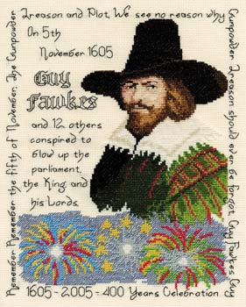
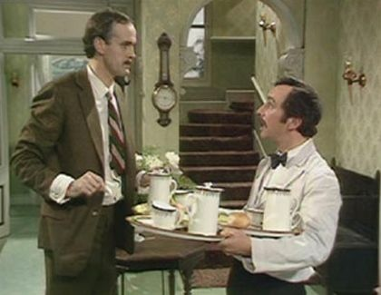
Did you ever watch “Fawlty Towers” with John Cleese and the ‘Spanish’ waiter ‘Manuel’? ‘Manuel’ was in the news this past week when two BBC presenters had to resign over inappropriate comments left on his telephone about his (real-life) granddaughter. In the series, ‘Manuel’s’ acting was so good that it was impossible not to know that he was not Spanish. Unfortunately, the presenters, like many presenters, get too big for their boots and think they can say or do anything they like. (This could also apply to Arnold Schwarzenegger and the very insulting remarks he made about Obama’s physical stature at a McCain rally a few days ago.)
Well you have your presidential elections on Wednesday, which in HK is Nov 5th, which of course is Guy Fawkes day which commemorates the day in 1605 when Guy Fawkes and his Catholic co-conspirators were caught while trying to blow up the English parliament while the protestant King James I was present.
That’s about it for now. Managed to do more than expected.

Cheers

